Hands-on Lab

Session 3060

Build your first Omni-Bot:

A chat bot that helps handle

Service Management incidents

Robert Barron, IBM Cloud

**You must include the first two pages of this template.**

© Copyright IBM Corporation 2017

IBM, the IBM logo and ibm.com are trademarks of International Business Machines Corp., registered in many jurisdictions worldwide. Other product and service names might be trademarks of IBM or other companies. A current list of IBM trademarks is available on the Web at “Copyright and trademark information” at www.ibm.com/legal/copytrade.shtml.

This document is current as of the initial date of publication and may be changed by IBM at any time.

The information contained in these materials is provided for informational purposes only, and is provided AS IS without warranty of any kind, express or implied. IBM shall not be responsible for any damages arising out of the use of, or otherwise related to, these materials. Nothing contained in these materials is intended to, nor shall have the effect of, creating any warranties or representations from IBM or its suppliers or licensors, or altering the terms and conditions of the applicable license agreement governing the use of IBM software. References in these materials to IBM products, programs, or services do not imply that they will be available in all countries in which IBM operates. This information is based on current IBM product plans and strategy, which are subject to change by IBM without notice. Product release dates and/or capabilities referenced in these materials may change at any time at IBM’s sole discretion based on market opportunities or other factors, and are not intended to be a commitment to future product or feature availability in any way.

Table of Contents

Objectives 4

Initial setup 5

Create Slack Team 5

Sending an initial sample message from Impact 21

Sending a real event from Impact 27

Format the event sent to Slack. 36

Using a bot to update the event from Slack. 40

Advanced formatting of the event 48

References and extra material 48

# Objectives

ChatOps is a recent development in the field of Operations, wherein people use a single tool both to communicate amongst themselves and send & receive automated

commands.

The aim of this lab is to demonstrate some initial capabilities of NOI and Slack integration to show a simple MVP solution which will showcase capabilities.

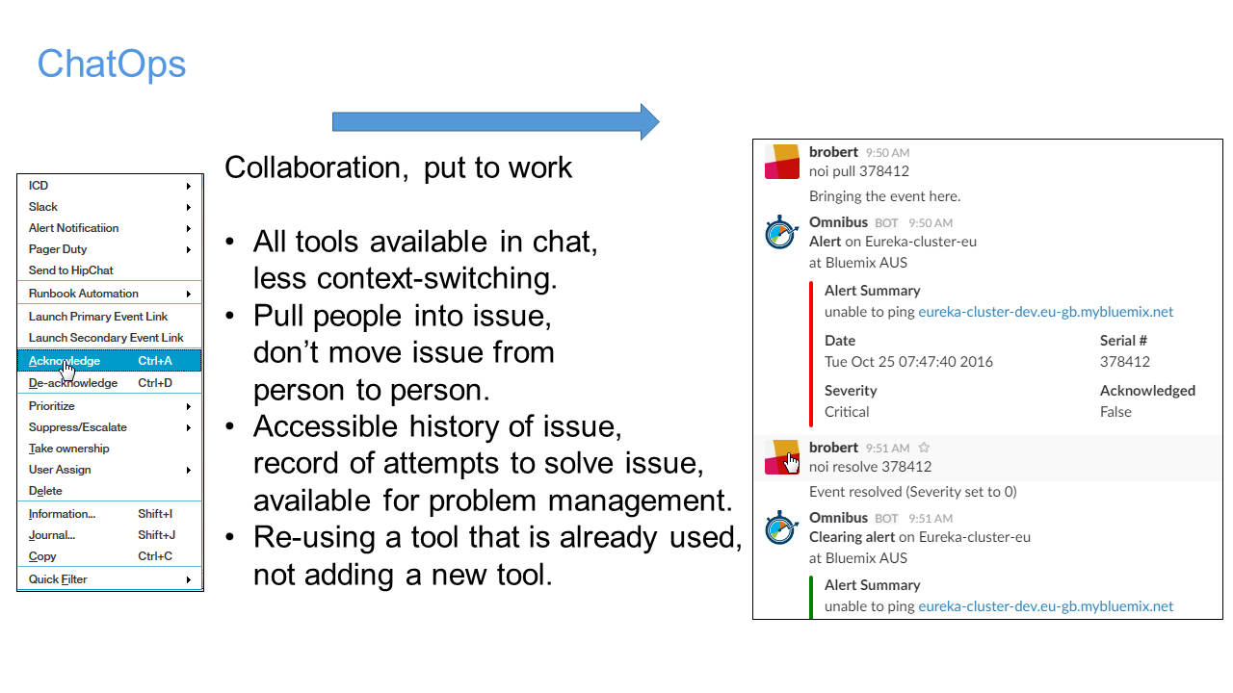Code can be downloaded from http://ibm.biz/chatops3060

# Initial setup

Open a terminal window and check your ip address using ifconfig -a.

Open the file /etc/hosts and make sure that the IP is correct. If it does not match, modify the IP address.

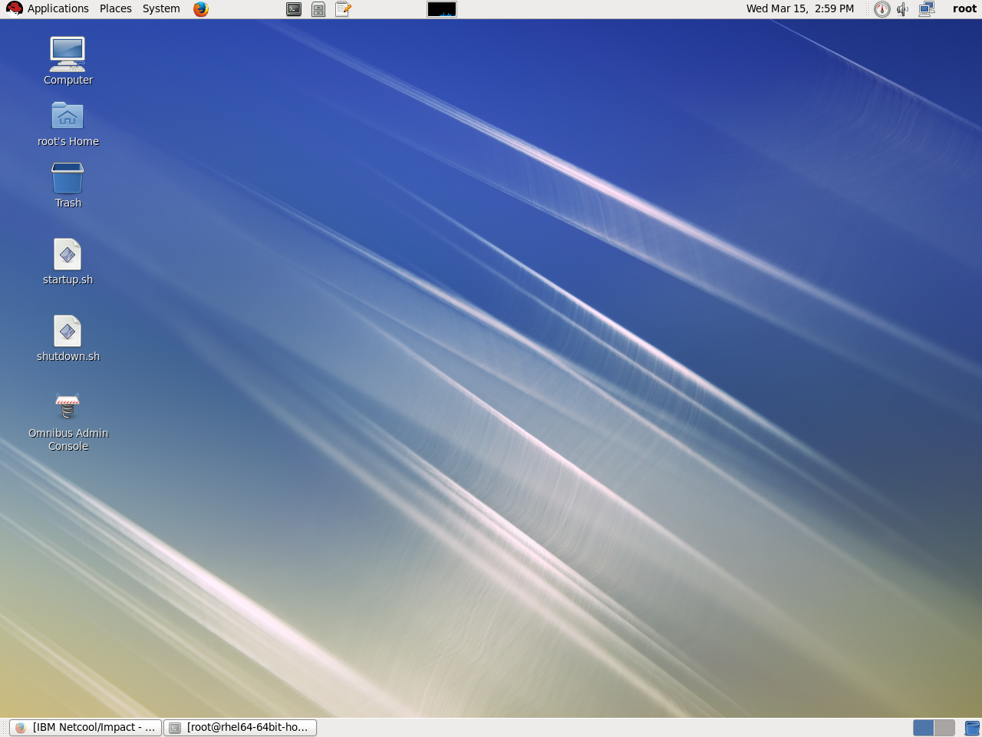Start the application stack by running the script startup.sh which is on the desktop.

# Create Slack Team

In this section, we will create the Slack team that will be used throughout the lab.

We will perform the following steps:

and create a token for API access. If you have administrative access to an existing Slack team, you may skip to step 11 by logging into your Slack.

|  |
| --- |
| 1. Go to slack main page [www.slack.com](http://www.slack.com) and create a new team |
| 01 LoginToCreateTeam |
|  |
| 1. Check your email and verify your team |
| 02 Verify Screen |
|  |

|  |
| --- |
| 1. Enter your name |
| 03 Name details |
|  |
| 1. Set your password |
| 04 Password |
|  |

|  |
| --- |
| 1. Fill in basic details about the team |
| 05 Company |
|  |
| 1. Fill in company name |
| 06 Company Name |
|  |

|  |
| --- |
| 1. Choose your Slack domain |
| 07 Domain |
|  |
| 1. Agree to the terms (you have no choice, really!) |
| 08 Terms |
|  |

|  |
| --- |
| 1. You may skip this step |
| 09 Invitations |
|  |
| 1. You have logged into your new Slack |
| 10 Welcome |
|  |

|  |
| --- |
| 1. Open the menu to "Apps and Integrations" |
| 11 menu Apps |
|  |
| 1. In the opened screen, choose the menu option Build |
| 12 apps |
|  |

|  |
| --- |
| 1. Select "Start Building" |
|  |

|  |
| --- |
| 1. Choose a name for your app (myBot, for example) |
| 15 create an app |
|  |
| 1. Congratulations – you have an app! Scroll down and record the Client ID and Client Secret |
|  |
|  |

|  |
| --- |
| 1. Choose OAuth & Permissions from the menu |
|  |
| 1. Enter <https://slack.com/oauth/authorize> in the OAuth settings |
| 17 oauth success |
|  |
| 1. Success! |
| 17 outh link |
|  |

|  |
| --- |
| 1. Create a bot user |
| 18 bot user |
|  |
| 1. Success! |
| 18 bot user 2 |
|  |

|  |
| --- |
| 1. Download and edit the file <https://github.com/RobertJBarron/2017-InterConnect-3060/blob/master/SlackButtonForOAUTH_template.html>. Edit the file and enter the clientID from step 15 and open the file in a browser |
|  |
|  |
| 1. After pressing the button, choose your Slack team to give access to (this step depends on your existing Slack settings, you may not see it) |
| 22 give access |
|  |

|  |
| --- |
| 1. Authorize the permissions |
| 23 authorize |
|  |
| 1. Record the "errorcode" in the browser URL. This is the section of text between "code=" and "&state" |
| 24 error code |
|  |

|  |
| --- |
| 1. Go to the Slack api page <https://api.slack.com/methods/oauth.access/test> and enter the Client ID and Secret from step 16 and code from step 24 (you have 10 minutes before the code expires) |
| 25 aouth 1of 2 |
|  |
| 1. Record the access tokens you receive (your own and the bot's) |
| 26 aouth 2of 2 |
|  |

Test your tokens using the command

curl -X POST -d "channel=%23general&text=Test%20Message" -d "token=__YourTokenHere__" <https://slack.com/api/chat.postMessage>

Verify that there a difference between running he command with each Token.

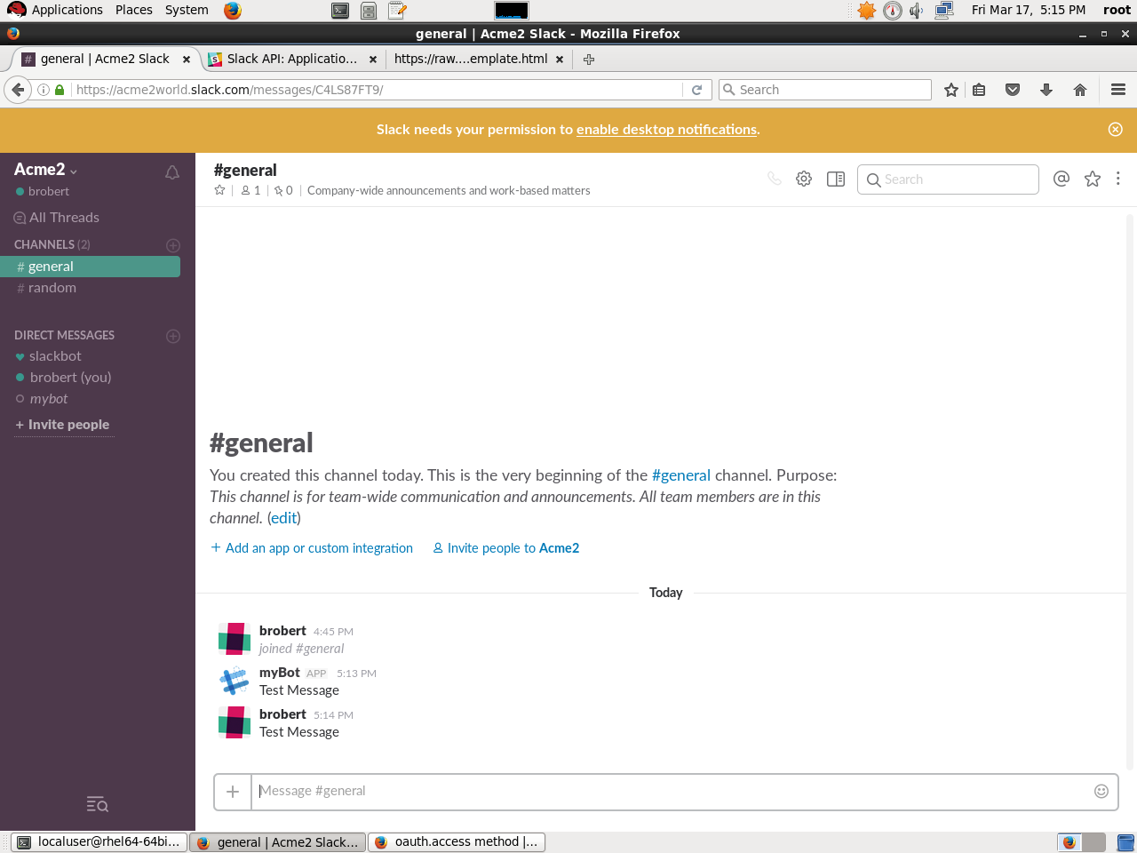

# Sending an initial sample message from Impact

We will use Impact to send the initial event to Slack.

|  |
| --- |
| 1. Export the Slack server certificate using the following command: echo -n | openssl s_client -connect slack.com:443 | sed -ne '/-BEGIN CERTIFICATE-/,/-END CERTIFICATE-/p' > /tmp/slack.cert |
| 1. Once you have the exported the certificate, you must load it into Impact by running the following command: /opt/IBM/tivoli/impact/sdk/bin/keytool -importcert -alias Slack-IC17-3060 -file /tmp/slack.cert -keystore /opt/IBM/tivoli/impact/wlp/usr/servers/NCI/resources/security/trust.jks -storepass impactadmin  |  | | --- | |  |   Respond "yes" when asked whether to trust the certificate. |
| 1. Restart Impact using the commands /opt/IBM/tivoli/impact/bin/stopImpactServer.sh /opt/IBM/tivoli/impact/bin/startImpactServer.sh |

|  |
| --- |
| 1. Open a new Firefox tab and login to Impact. <http://localhost:17310/ibm/console> (or the bookmark Logon IBM Netcool/Impact 7.1.0.7)     User/password is impactadmin/impactadmin |

|  |
| --- |
| 1. Click "Global" and then "Create Project" |
|  |
| 1. Create a new project called "Slack" and add the datasource "ObjectServerForNOI" |
|  |
| 1. Create a new IPL policy |
|  |

|  |
| --- |
| Enter the following contents into the Policy and update the value of the Slack token to your own token: SlackToken = "__YOUR_TOKEN_HERE___";  SlackChannel = "general";  SlackPayload = "text=hello world";    HTTPPort=443;  Protocol="https";  ChannelKey="";  Method="POST";  AuthHandlerActionTreeName="";  FormParameters=null;  FilesToSend=null;  HeadersToSend=null;  HTTPHost="slack.com";  Path="/api/chat.postMessage";  HttpProperties=NewObject();  HttpProperties.ContentType="application/x-www-form-urlencoded";  payload = "token=" + SlackToken + "&channel=" + SlackChannel + "&" + SlackPayload ;  HttpProperties.Content=( payload );  Log( HttpProperties);  rawResult=GetHTTP(HTTPHost, HTTPPort, Protocol, Path, ChannelKey, Method, AuthHandlerActionTreeName, FormParameters, FilesToSend,  HeadersToSend, HttpProperties);  Log (ThePage);// "ThePage" is useful for diagnosing http errors  Log (ResultCode);// -> Status Code associated with HTTP call  Log (HeadersSent); // -> Http Request Headers  Log (HeadersReceived);// -> Http Response Headers  Log (ErrorReason);// -> Returns the status text associated with the latest response.  result = ParseJSON(rawResult);  Log(result);  Log("----------------------------------------------------------"); |

|  |
| --- |
| 1. Validate the syntax of the code and run the policy. |
|  |
| 1. Check the contents of the policy log file at : /opt/IBM/tivoli/impact/logs/ |
|  |

# Sending a real event from Impact

|  |  |
| --- | --- |
| 1. Create a file and instert the following SQL commands   alter table alerts.status add Slack integer; | |
|  | |
|  | | |
| go | | |
|  | | |
|  | | |
| insert into alerts.conversions values ('Slack0', 'Slack', 0, 'Not Sent'); | | |
|  | | |
|  | | |
| go | | |
|  | | |
|  | | |
| insert into alerts.conversions values ('Slack1', 'Slack', 1, 'Queued'); | | |
|  | | |
|  | | |
| go | | |
|  | | |
|  | | |
| insert into alerts.conversions values ('Slack2', 'Slack', 2, 'Sent'); | | |
|  | | |
|  | | |
| go | | |
|  | | |
|  | | |
| alter table alerts.status add SlackChannel varchar (32); | | |
|  | | |
| go |

|  |
| --- |
| 1. In Impact, open the "Services" tab and create a new service called "Slack" |
|  |
| 1. Move to the tab "Event Mapping" and check the option "Get Updated Events" |
|  |

|  |
| --- |
| 1. Add a new entry to the "Event Mapping Table" which will run the policy you created when the event "Slack = 1" occurs (mark it active) |
|  |

|  |
| --- |
| 1. Save the service |
|  |
| 1. Start the Service |
|  |
| 1. Reopen the Slack policy that you created in the previous step and modify it in the following ways:   These changes will make sure that the event is only sent once. The policy is triggered by the service when the value of Slack=1 and the policy itself changes the value to 2 when it completes. |

|  |
| --- |
| 1. Login to DASH at <http://localhost:16311/ibm/console> with the user/password of ncoadmin/nocadmin (note that you cannot be logged into to DASH and Impact during the same session – you will either need to logout of Impact or open a private tab for the DASH session) |

|  |
| --- |
| 1. Open the "Tool config" menu |
|  |
| 1. Create a new SQL tool called "SendToSlack" and enter the following command :  update alerts.status set Slack=1 where Serial in ($selected_rows.Serial); |
|  |
| 1. Save the tool |
|  |
| 1. Open the "Menu Configuration" tab and choose the "alerts" menu to modify |
|  |
| 1. Modify the "alerts" menu by moving the SendToSlack tool to the right |
|  |
| 1. Rename the tool in the menu to "Send event to Slack" |
|  |

|  |
| --- |
| 1. Open the event viewer tab |
|  |
| 1. right click an event to verify that you see the new tool. |
|  |
| 1. Right click again and show the event details, verify that the event has been modified. |
|  |
| 1. Check Slack and see if your event appears |

# Format the event sent to Slack.

|  |
| --- |
| 1. Create a new Impact policy with the following contents:   SlackToken = "__REPLACE_WITH_TOKEN";  DASH_Server = "https://REPLACE_WITH_SERVER_FQDN_OR_IP:16311/ibm/console";    HTTPPort=443;  Protocol="https";  ChannelKey="";  Method="POST";  AuthHandlerActionTreeName="";  FormParameters=null;  FilesToSend=null;  HeadersToSend=null;  HTTPHost="slack.com";  Path="/api/chat.postMessage";  HttpProperties=NewObject();  HttpProperties.ContentType="application/x-www-form-urlencoded";  SlackChannel = "general";  SlackNode = @Node;  SlackTime = LocalTime(@LastOccurrence, "EEE MMM dd HH:mm:ss yyyy");  SlackMessage = replace(@Summary,'"','');  if (@Severity == 0 ) { SlackSeverity = "Clear"; SlackColour = "#00FF00"; PreText = "*Clearing alert*"; } elseif  (@Severity == 1 ) { SlackSeverity = "Indeterminate"; SlackColour = "#808080"; PreText = "*Information*"; } elseif  (@Severity == 2 ) { SlackSeverity = "Warning"; SlackColour = "#00FFFF"; PreText = "*Alert*"; } elseif  (@Severity == 3 ) { SlackSeverity = "Minor"; SlackColour = "#FFFF00"; PreText = "*Alert*"; } elseif  (@Severity == 4 ) { SlackSeverity = "Major"; SlackColour = "#FFA500"; PreText = "*Alert*"; } elseif  (@Severity == 5 ) { SlackSeverity = "Critical"; SlackColour = "#FF0000"; PreText = "*Alert*"; } else  { SlackSeverity = "Indeterminate"; SlackColour = "#808080"; PreText = "*Information*"; }    if (@Acknowledged == 0) { SlackAcked = 'False'; } else { SlackAcked = 'True';}  SlackSerial = @Serial; // Need to use local variables so that Impact will not try to update them fields after we pass them as parameters.  SlackIdentifier = @Identifier; // Need to use local variables so that Impact will not try to update them after we pass them as parameters.  SlackPayload =  "mrkdwn=true&username=Omnibus&icon_emoji=:itsm:&text=" + PreText + " on " +  SlackNode + "&" ;    Attachments = "attachments=[ { \"color\":\"" + SlackColour + "\",\"ts\":" + @LastOccurrence + ",\"text\": \"" +  "\" , \"mrkdwn_in\": [\"text\"], \"fields\": [ " +  "{\"title\": \"Alert Summary" + " (Serial #" + SlackSerial + ")" + ClassText + "\" ,\"value\": \"" +  SlackMessage + "\",\"short\": false}" +  "]}] " ;  // Post the main body  payload = "token=" + SlackToken + "&channel=" + slackChannel + "&" + slackPayload ;  HttpProperties.Content=( payload );  Log( HttpProperties);  rawResult=GetHTTP(HTTPHost, HTTPPort, Protocol, Path, ChannelKey, Method, AuthHandlerActionTreeName, FormParameters, FilesToSend,  HeadersToSend, HttpProperties);  Log (ThePage);// "ThePage" is useful for diagnosing http errors  Log (ResultCode);// -> Status Code associated with HTTP call  Log (HeadersSent); // -> Http Request Headers  Log (HeadersReceived);// -> Http Response Headers  Log (ErrorReason);// -> Returns the status text associated with the latest response.  result = ParseJSON(rawResult);  Log(result);  Log("----------------------------------------------------------");  slackResultCode = ResultCode;  @Slack = 2;  ReturnEvent(EventContainer); |
| 1. Correct the values for the Slack token and the DASH IP. |
| 1. Modify the Impact service mapping to use the new policy instead of the old one and stop/start the service (see steps 4 & 5) |

# Using a bot to update the event from Slack.

|  |
| --- |
| 1. Modify the Objectserver configuration file to allow remote HTTP access modify the file /opt/IBM/tivoli/netcool/omnibus/etc/AGG_P.props   NHttpd.EnableHTTP: TRUE NHttpd.ListeningPort: 7070 NRestOS.Enable: TRUE |
| 1. Restart the objectserver with the following commands:   /opt/IBM/tivoli/netcool/omnibus/bin/nco_pa_stop -process MasterObjectServer  /opt/IBM/tivoli/netcool/omnibus/bin/nco_pa_stop -process MasterObjectServer  Use the root password when asked. |
| 1. Test that you have remote access by running the command  telnet localhost 7070 |
| 1. Open a cmd window and run the following commands as root:   curl -sL [https://rpm.nodesource.com/setup_6.x |](https://rpm.nodesource.com/setup_6.x%20|)sudo -E bash -  yum install -y nodejs  These commands install node.js to the server |
| 1. Run the following command as root:   npm install -g yo generator-hubot  This command installs a bot "generator". |
| 1. Run the following command as root:   npm install -g node-omnibus  This command installs a node.js library that can converse with the ObjectServer over REST |
| 1. The following commands must be run as localuser   su localuser  cd ~  mkdir bot  cd bot  yo hubot |

|  |
| --- |
| 1. Enter your own details for the bot name and description, choose "slack" as the adaptor type |
|  |
| 1. Run the command "ls -ltr" and you will see the following files: |
|  |
| 1. Edit the file package.json and add a dependency to the node-omnibus component:   "node-omnibus": "^0.1.1" |

|  |
| --- |
| Create the file noi.coffee in the ./scripts subdirectory and insert the following code into it: console.log ('Omnibus = ' + process.env.HUBOT_OMNIBUS_HOST)  omnibus = require('node-omnibus')  request = require('request')  HubotSlack = require 'hubot-slack'  noiChannelName = ""  omnibusConnection = omnibus.createConnection(  host: process.env.HUBOT_OMNIBUS_HOST  port: '8080'  user: process.env.HUBOT_OMNIBUS_USER  password: process.env.HUBOT_OMNIBUS_PASSWORD)  module.exports = (robot) ->  robot.hear /noi ack (.*)/i, (msg) ->  sql = 'UPDATE alerts.status set Acknowledged = where Serial=' + msg.match[1]  omnibusConnection.sqlCommand sql, (err, rows, numrows, coldesc) ->  console.log "err:" + err  if numrows == 0  msg.send "I can't find any event with a serial number of " + msg.match[1]  msg.send "Perhaps the event has been closed already? Otherwise, try another serial number."  else  msg.send "Event acknowledged"    robot.hear /noi deack (.*)/i, (msg) ->  sql = 'UPDATE alerts.status set Acknowledged = 0 where Serial=' + msg.match[1]  omnibusConnection.sqlCommand sql, (err, rows, numrows, coldesc) ->  console.log "err:" + err  if numrows == 0  msg.send "I can't find any event with a serial number of " + msg.match[1]  msg.send "Perhaps the event has been closed already? Otherwise, try another serial number."  else  msg.send "Event de-acknowledged" |
| 1. Run the bot using the command  HUBOT_OMNIBUS_PASSWORD= HUBOT_OMNIBUS_HOST=localhost PORT=7070 HUBOT_SLACK_TOKEN=<<YOURTOKENHERE>> ./bin/hubot --adapter slack |
| 1. From the Slack window, invite the bot to your slack channel with the command /invite <botname> |
| 1. In the DASH event viewer, choose an event and view it’s details to find the Serial number. Run the command "noi ack <serial#>" in the Slack command and verify that it has been acknowledged in the DASH event viewer. |
| 1. Stop the bot using ctrl-C and update the file noi.coffee with the following rows:   robot.hear /noi journal (.*?) (.*)/i, (msg) ->  dt = Date.now()  dt = dt / 1000  sql = 'Insert into alerts.journal (KeyField, Serial, UID, Chrono, Text1) values (\'' + msg.match[1] + '_' + dt + '\',' + msg.match[1] + ', 10000 ,' + dt + ', \'' + msg.match[2] + '\')'  console.log sql  omnibusConnection.sqlCommand sql, (err, rows, numrows, coldesc) ->  console.log "Err=" + err  msg.send "Journal entry added" |
| 1. Start the bot and run the command "noi journal <serial#> This is a test". Check in the event viewer to see if the event's journal has been updated. |
| 1. Stop the bot using ctrl-C and update the file noi.coffee with the following rows:     robot.hear /noi sev (\d) (.*)/i, (msg) ->  sql = 'UPDATE alerts.status set Severity = ' + msg.match[1] + ' where Serial=' + msg.match[2]  omnibusConnection.sqlCommand sql, (err, rows, numrows, coldesc) ->  console.log "Err=" + err  if numrows == 0  msg.send "I can't find any event with a serial number of " + msg.match[2]  msg.send "Perhaps the event has been closed already? Otherwise, try another serial number."  else  msg.send "The event severity has been set to " + msg.match[1] |
| 1. Start the bot and run the command "noi sev <serial#> 5". Check in the event viewer to see if the event's priority has been changed to Critical/Red. |
| 1. Stop the bot using ctrl-C and update the file noi.coffee with the following rows:   robot.hear /noi resolve (.*)/i, (msg) ->  sql = 'UPDATE alerts.status set Severity = 0,CASE_ICD_Status=\'RESOLVED\' where Serial=' + msg.match[1]  omnibusConnection.sqlCommand sql, (err, rows, numrows, coldesc) ->  console.log "Err=" + err  msg.send "Event resolved (Severity set to 0)" |
| 1. Start the bot and run the command "noi resolve <serial#>". Check in the event viewer to see if the event's priority has been changed to Clear/Green. |
| 1. Stop the bot using ctrl-C and update the file noi.coffee with the following rows:   robot.hear /noi show (.*)/i, (msg) ->  query = 'SELECT Serial, Summary, Severity, Node, Acknowledged, LastOccurrence from alerts.status where Serial=' + msg.match[1]  omnibusConnection.query query, (err, rows, numrows, coldesc) ->  console.log err  i = 0  msg.send  text : rows[i].Summary  attachments: [ {  title: 'Node'  text: rows[i].Node  fields: [ {  short : true  title : 'Severity'  value : rows[i].Severity  },{  title : 'Acknowledged'  value : rows[i].Acknowledged  short : true  },{  title : 'LastOccurrence'  value : rows[i].LastOccurrence  short : true  },{  title : 'Serial'  value : rows[i].Serial  short : true  } ]  } ]  username: process.env.HUBOT_SLACK_BOTNAME  as_user: true |
| 1. Start the bot and run the command "noi show <serial#> " |

# Advanced formatting of the event

# References and extra material

To be done